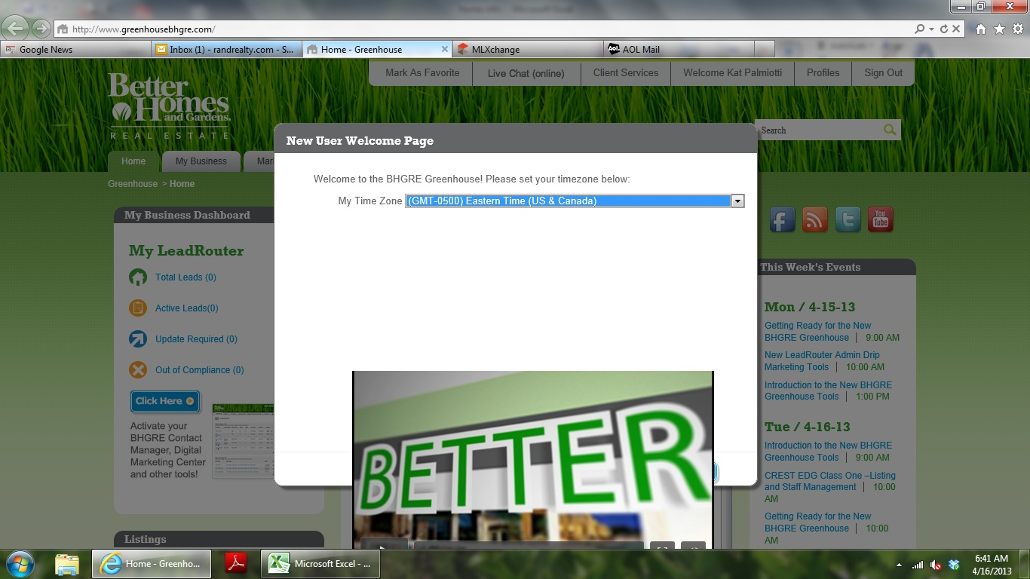When you first sign into Greenhouse, you will be asked to select your time zone. One you have selected Eastern, the video blocks the NEXT Button. Click the Blue sliver next to the video to advance the screen.
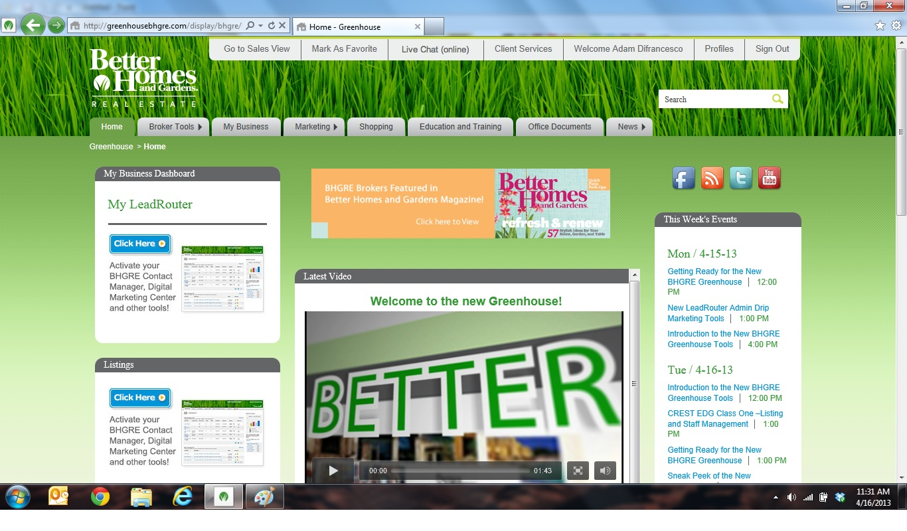After you have gotten past the first set up, you have to activate the BHGRE Contact Manager, Digital Marketing Center.
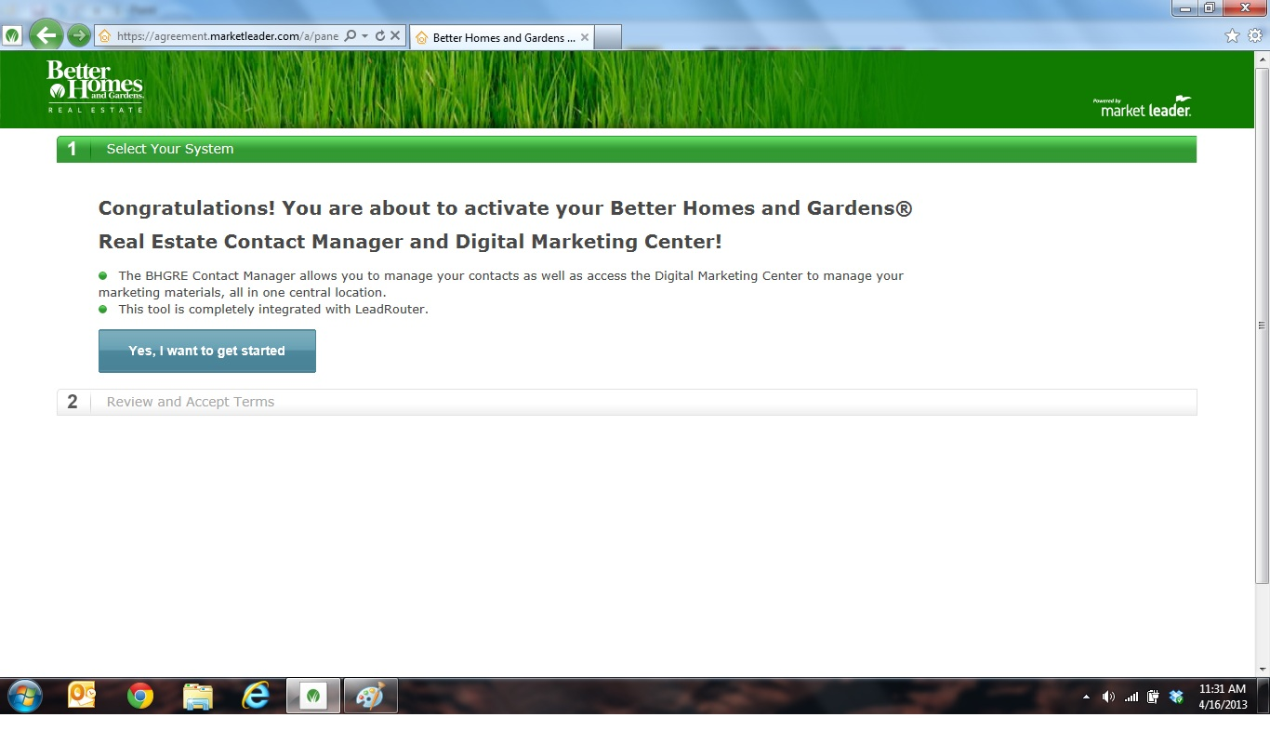You will have 3 steps to complete. Step one is click, Yes, I want to get started
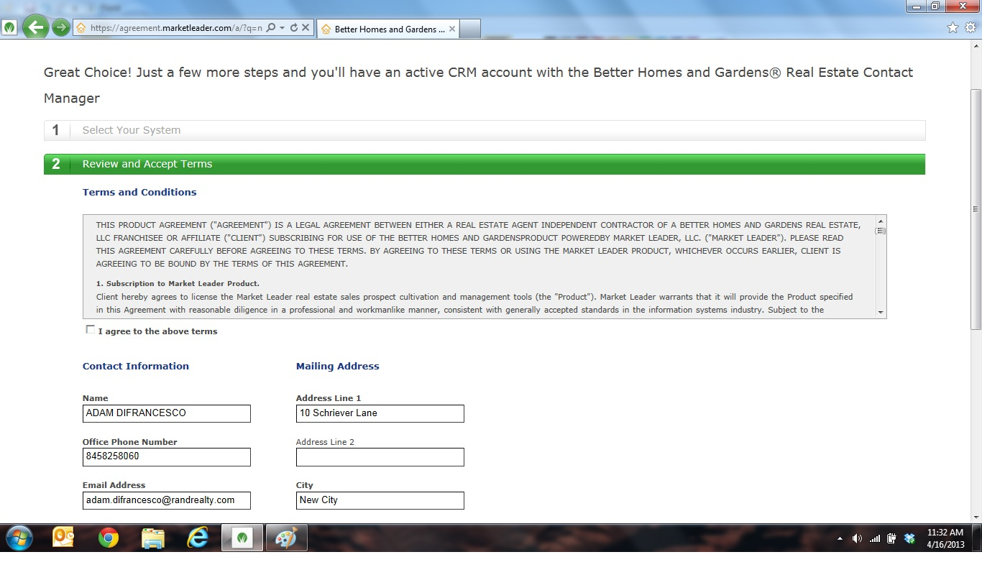Step 2 is to Review and Accept Terms. Check to make sure you name and office information is correct. Then scroll down and click continue.
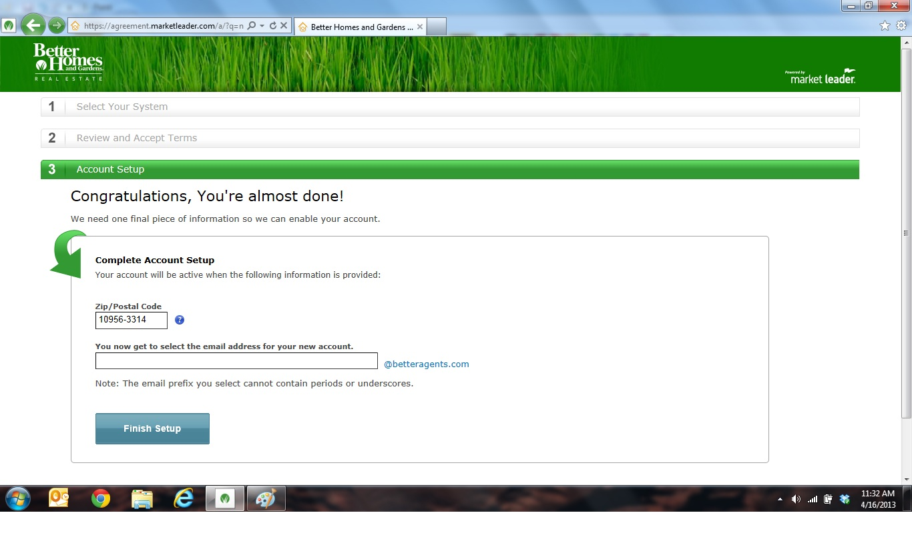Step 3, you have to create a BetterAgents.com email address. It cannot contain a “.” Or “-_”
Then click Finish Setup
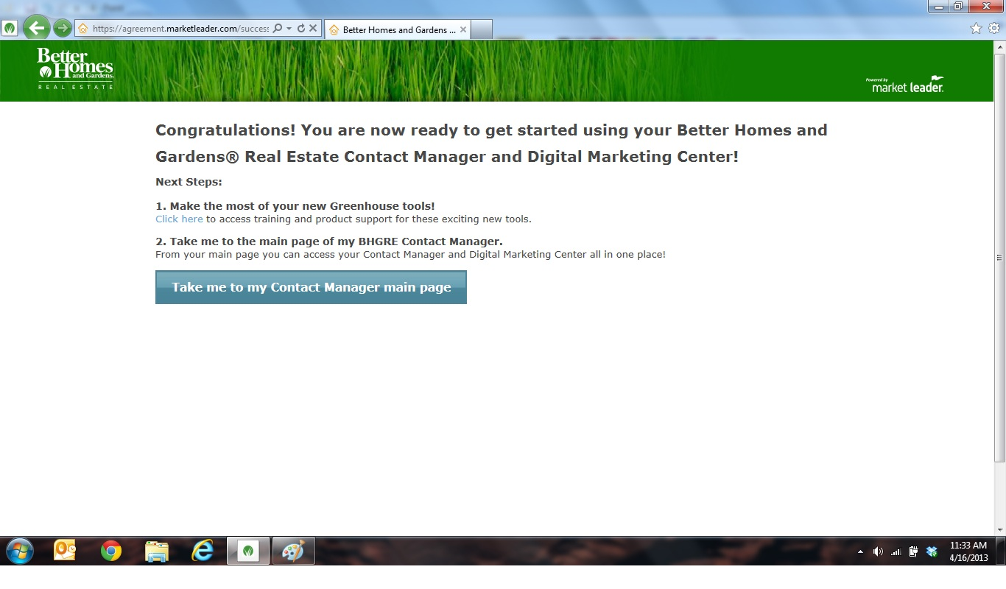Step up is now complete. Click to go to Contact Manger.
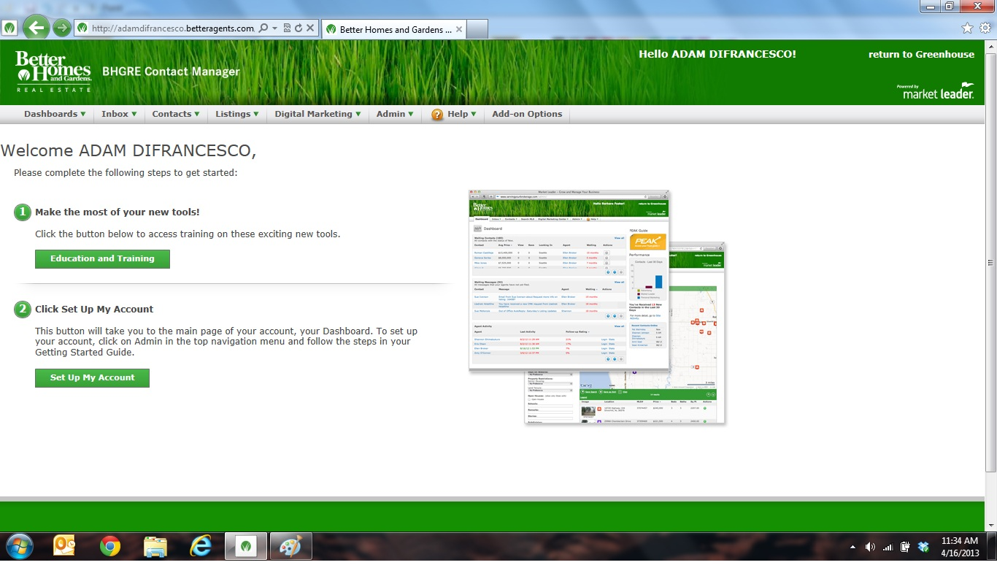To get back to HOME SCREEN, click Return to Greenhouse in top right corner.
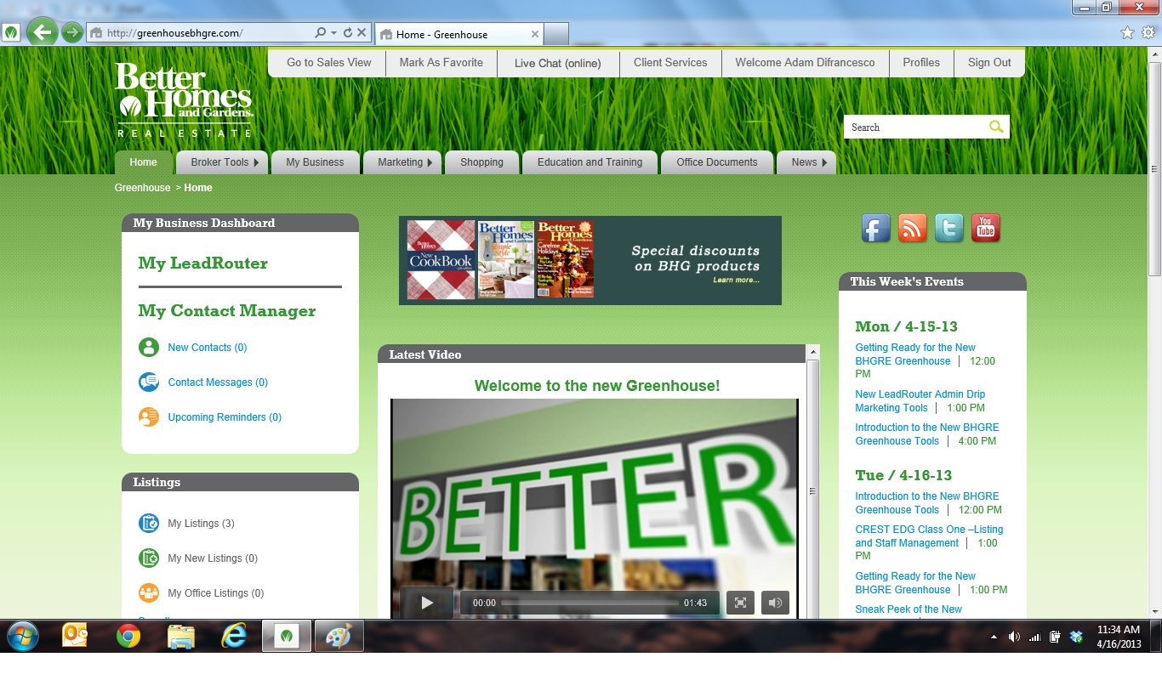New Home Screen Looks as follows.
My Lead Router will take you to Lead Router.
My Contact Manager will take you to the GREENHOUSE contact manager only.

